**Project Design Phase-II Data Flow Diagram & User Stories**

|  |  |
| --- | --- |
| Date | 18 November 2022 |
| Team ID | PNT2022TMID47137 |
| Project Name | Natural Disaster Intensity Analysis and Classification using Artificial Intelligence |
| Maximum Marks | 4 Marks |

**Data Flow Diagrams:**

A Data Flow Diagram (DFD) is a traditional visual representation of the information flows within a system. A neat and clear DFD can depict the right amount of the system requirement graphically. It shows how data enters and leaves the system, what changes the information, and where data is stored.

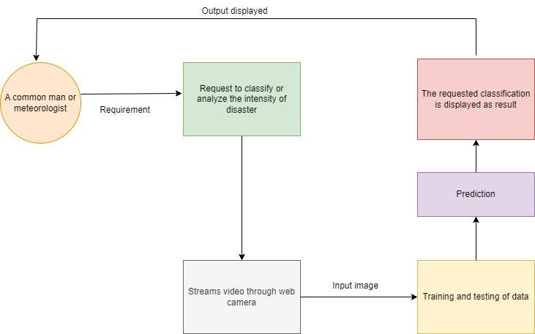

**User Stories**

Use the below template to list all the user stories for the product.

|  |  |  |  |  |  |  |
| --- | --- | --- | --- | --- | --- | --- |
| **User Type** | **Functional**  **Requirement**  **(Epic)** | **User Story**  **Number** | **User Story / Task** | **Acceptance criteria** | **Priority** | **Release** |
| Customer  (Mobile user) | Registration | USN-1 | As a user, I can register for the application by entering my email, password, and confirming my password. | I can access my account / dashboard | High | Sprint-1 |
|  |  | USN-2 | As a user, I will receive confirmation email once I have registered for the application | I can receive confirmation email & click confirm | High | Sprint-1 |
|  |  | USN-3 | As a user, I can register for the application through Gmail |  | Medium | Sprint-1 |
|  | Login | USN-4 | As a user, I can log into the application by entering email & password |  | High | Sprint-1 |
|  | Dashboard |  |  |  |  |  |
| Customer (Web user) |  | USN-5 | As a user, you can view edit your personal details | I can edit and view my details | Low | Sprint-2 |
|  |  | USN-6 | As a user, you can determine future climatic changes | I can check on information about weather forecast | High | Sprint-2 |
| Administrator |  | USN-7 | As a admin you can provide or display the requested details from user such as displaying forecasted weather of the place | I can display forecasted details about weather. | Medium | Sprint3 |